General Aviation Joint Safety Committee
Non-required Safety Equipment
Outreach Guidance Document
2022/12-07-274(I)PP
This outreach guidance is provided to all FAA and aviation industry groups that are participating in outreach efforts sponsored by the General Aviation Joint Safety Committee (GAJSC). It is important that all outreach on a given topic is coordinated and is free of conflicts. Therefore, all outreach products should be in alignment with the outline and concepts listed below for this topic.
Outreach Month: June 2024

Topic: After-market Safety Equipment
The FAA and industry will conduct a public education campaign emphasizing the value of and streamlined process for equipage with after-market safety equipment.
Background:
The GAJSC feels that installation and use of after-market safety equipment can significantly reduce the likelihood of some general aviation accidents. The committee is particularly interested in angle of attack indicators, engine monitoring equipment, enhanced and synthetic vision systems. They also support reducing regulatory burdens on installation and certification of safety equipment installations.
Teaching Points:
- A number of technologies have proven useful in reducing the likelihood of general aviation accidents.
- As with all technologies, pilots must be thoroughly familiar with limitations and proper operation of the equipment.
- FAA recognizes that reducing regulatory burden can result in increased safety equipment installation and use.
- Pilot proficiency is still the most profound influence on flight safety.

References:
- Press Release – FAA Clears Path for Installation of Angle of Attack Indicators in Small Aircraft
  - http://www.faa.gov/news/press_releases/news_story.cfm?newsid=15714
- GAJSC Documents and Reports
  - http://www.gajsc.org/document-center/

Abstract: Lasting 10 to 20 minutes, this presentation acquaints the audience with available after-market safety equipment options for general aviation pilots.
Format: Information Briefing - Power Point presentation
Required Personnel – FAASTeam Program Manager or designated FAASTeam Rep (s)
Optional Personnel – CFIs and DPEs who can speak after-market safety equipment.
AFS 850 Support:
In addition to this guidance document, a Power Point presentation that supports the program is provided. FPMs and presenters are encouraged to customize this presentation to reflect each individual program.

Slides | Script
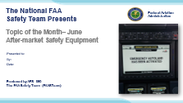 | Slide 1  2022/12-07-274(I)PP Original Author: John Steuernagle 08/17/2023; POC Kevin Clover AFS-850 National FAASTeam Program Manager (Operations), Office (562-888-2020 revised by (Name) (MM/DD/YYYY)  Presentation Note: This is the title slide for After-market Safety Equipment  Presentation notes (stage direction and presentation suggestions) will be preceded by a Bold header: the notes themselves will be in Italic fonts.  Program control instructions will be in bold fonts and look like this: (Click) for building information within a slide; or this: (Next Slide) for slide advance.  Some slides contain background information that supports the concepts presented in the program.  Background information will always appear last and will be preceded by a bold Background: identification.  We have included a script of suggested dialog with each slide. Presenters may read the script or modify it to suit their own presentation style.  The production team hope you and your audience will enjoy the show. Break a leg!  (Next Slide)
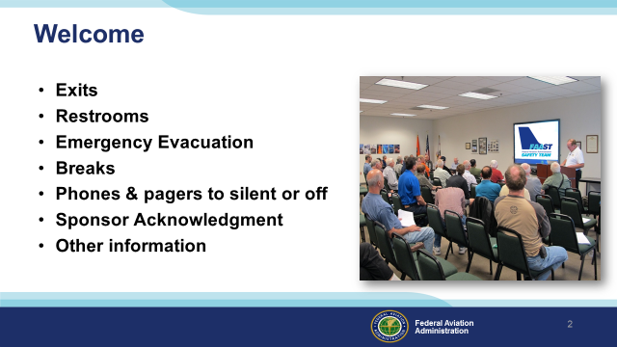 | Slide 2  Presentation Note: Here’s where you can discuss venue logistics, acknowledge sponsors, and deliver other information you want your audience to know in the beginning.  You can add slides after this one to fit your situation. (Next Slide)
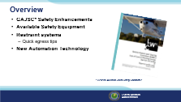 | Slide 3  The General Aviation Joint Safety Committee has determined that safety General Aviation Safety can be improved through installation of after-market safety equipment.  Today we’ll be discussing safety equipment that you can add to your aircraft. We’ll emphasize restraint systems and give you some tips for expeditious aircraft egress.  Presentation Note: If you’ll be discussing additional items, add them to this list.  (Next Slide)
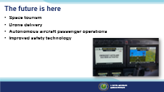 | Slide 4  The future is definitely here. Sub-orbital flights and even trips to the International Space Station are available to those who are willing and able to part with the cost of a ticket.  Drones are delivering packages.  And soon we’ll see passenger-carrying operations in autonomous aircraft; although it’s hard to imagine certificated pilots eagerly seeking opportunities to ride in aircraft that they, or any human for that mater, have no way to control.  General Aviation is also benefitting from the technology explosion. (Click)  Some of our aircraft are capable of navigating to and airport and landing without any human input beyond activating an emergency landing system.  Safety technologies are making their way to the general aviation fleet at an ever-increasing pace and those of us who can afford a new aircraft or to upgrade and older one would do well to consider safety options. In the meantime, there are some simple, inexpensive, and effective things we can do right now that will improve GA safety.  (Next Slide)
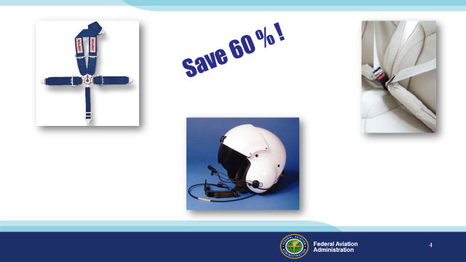 | Slide 5  If you saw a sign that said just this “Save 60%!” would you want to know more?  Well in Alaska we could reduce General Aviation fatalities by 60% through adoption of these technologies; (Click)  - four or five-point seatbelts (Click)  - or airbag seatbelts (Click)  - and helmets.  Granted, many Alaskan accidents occur off airport in low-speed aircraft so the impact forces are less but it’s certainly something to think about when you’re replacing your seatbelts.  We realize that helmets are a tough sell but their use has increased markedly in the helicopter and bush pilot communities both in Alaska and the “lower 48” states.  (Next Slide)
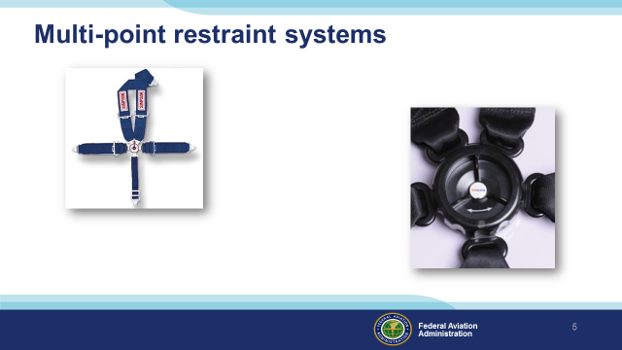 | Slide 6  Many of us still fly with single belt restraint systems but adding shoulder belts and anti-submarine restraints give you the best chance of sustaining minimal or no injury in many accident scenarios.  (Next Slide)
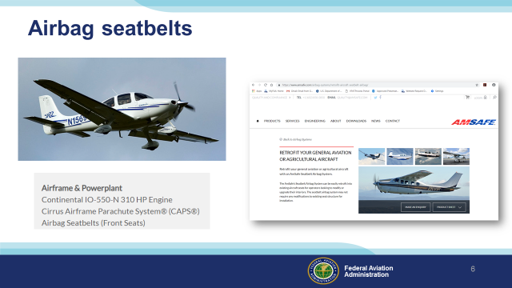 | Slide 7  Airbag seatbelts are another option worthy of consideration. Several aircraft manufacturers now provide them as standard equipment and there’s a growing after-market installation business.  (Next Slide)
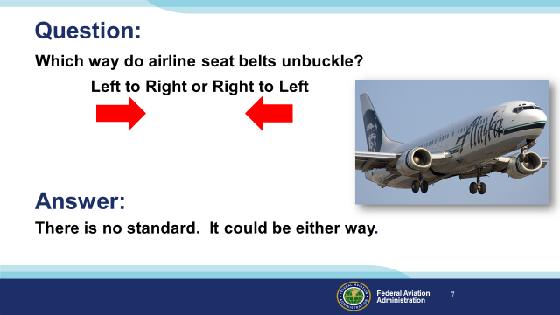 | Slide 8  We’ve all heard the airline safety briefing many times on many carriers so here’s a question:  Which way do airline seat belts unbuckle (Click)  – from left to right, or from right to left?  Presentation note: Ask the audience for a show of hands then: (Click)  The answer is there is no standard. It could be either way.  (Next Slide)
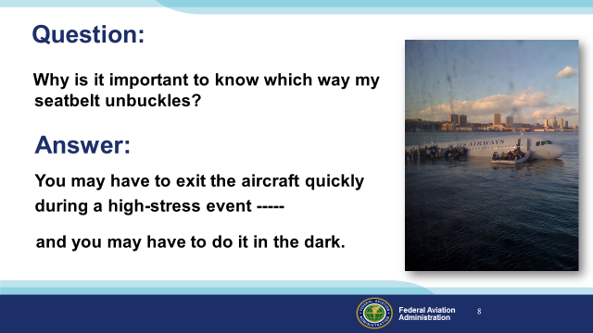 | Slide 9  Why does how your seatbelt works matter? (Click)  Well you may be very motivated to exit the aircraft. That motivation could compromise your thinking and that could result in a deadly delay. (Click)  And you may have to do it in the dark.  (Next Slide)
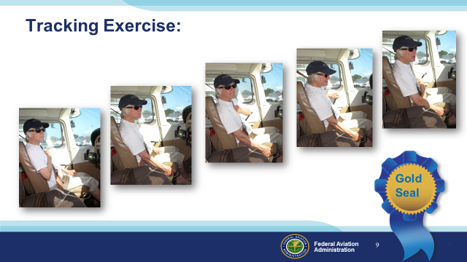 | Slide 10  Here’s an exercise that has been around for a while but it’s worthy of review and it will definitely improve your chances of doing the right things in the right sequence to exit your aircraft or even automobile quickly and safely in emergency situations. It works equally well in daylight or when vision is compromised by darkness, smoke, or injury. Please follow along as we go through the steps.  Presentation note: Encourage the audience to go through the motions from their seats.  First of all imagine you’re sitting in your usual seat in the airplane you usually fly. Visualize which hand you’ll use to open the exit closest to you. Have you got the picture?  Good – now take your other hand, make a fist and hold it against your sternum like this. Our sternum is something we always have with us and it’s easy to find – even in the dark. We’ll use it as a reference to find other important parts of the aircraft. (Click)  Now slide your hand from your sternum to your lap and from there to your seat. Get a good grip and keep you seat holding hand in position for the rest of the exercise. (Click)  Next take the hand not holding your seat and locate your sternum reference point. (Click)  From there track to your lap and then the door latch. In some airplanes you’ll have to track to 2 door latches.  Unlatch the door, push it open, and return to your reference point. (Click)  From there again track down to your lap and then to your seat belt release all the while holding tightly on to your seat with your other hand. Release your seat belt and prepare to exit. Don’t let go of your seat though. I’ll tell you when to do that. (Click)  This little exercise could save your life in an emergency and it’s worth a gold seal.  (Next Slide)
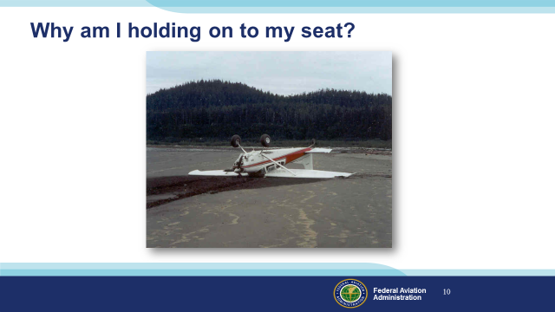 | Slide 11  Now I know you’re wondering why you’re still holding on to your seats when the whole object of the exercise was to undo the seatbelt and exit. (Click)  Answer – Because we might be upside down & unbuckling the belt without preparation could lead to a cracked skull. Also - some buckles are difficult or impossible to unlatch when they’re under load. You can use your seat holding hand to take the strain off the buckle before unlatching it.  (Next Slide)
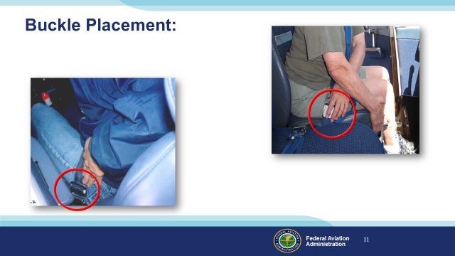 | Slide 12  Just one more thing about seat belts. Buckle placement is important. (Click)  In this illustration, the seat belt buckle is low on the pilot’s left side. With the door closed, the buckle will be under the armrest. If the door were jammed, precious time could be spent in cutting the seatbelt & finding another exit. (Click)  Here the buckle is low on the pilot’s right side and it’s unobstructed – a much better choice for buckle placement.  (Next Slide)
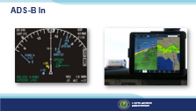 | Slide 13  Most of the general aviation fleet is now equipped with ADS-B Out technology but ADS-B In? Well, not so much. Panel mounted ADS-B In can run to tens of thousands of dollars, so it’s understandable that some aircraft owners are reluctant to make the investment. Economical external solutions are available though, and all can traffic and real-time weather information in easy-to-interpret graphical formats.  (Next Slide)
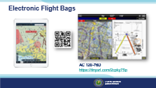 | Slide 14  Speaking of external solutions – Electronic Flight Bags have largely replaced paper charts. Integrated flight planning, weather, and aircraft position overlaid on moving maps are wonderful situational awareness assets. Chart updates that used to take hours can now be done in a few minutes. We do recommend dual display devices though, and many pilots carry paper sectional or WAC charts for backup. (Click)  FAAs Advisory Circular, AC 120-76D – Authorization for Use of Electronic Flight Bags contains the information you need to get started.  (Next Slide)  Background: AC 120-76D - Authorization for Use of Electronic Flight Bags (faa.gov) https://tinyurl.com/2cpky75p
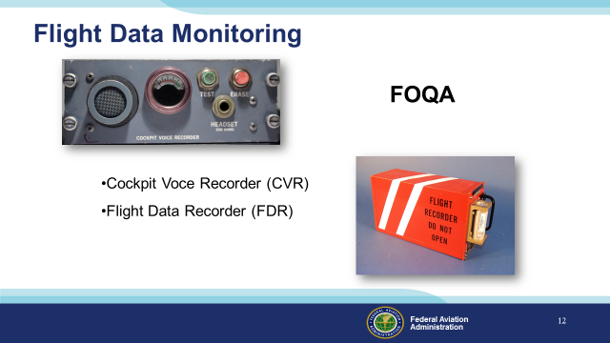 | Slide 15  In its’ simplest form, FDM consists of a cockpit voice recorder that records at least the most recent 15 minutes of crew conversations, and a flight data recorder that preserves such things as engine parameters, control position, heading, altitude, and airspeed data. (Click)  The equipment and processes to acquire and distribute the data are collectively known as Flight Operational Quality Assurance or FOQA (pronounced: Fohqua)  But this equipment is only for the big guys right? General Aviation aircraft don’t have anything like this ……………………. Or do they?  (Next Slide)
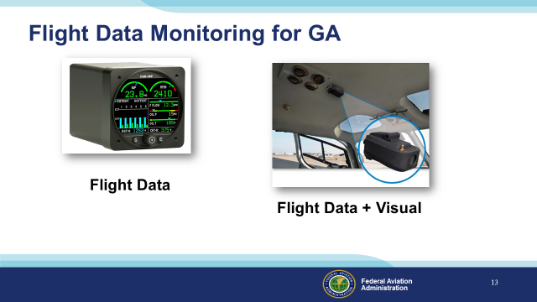 | Slide 16  While it’s true that most GA aircraft don’t have dedicated automatic flight data recording devices now; we will be able to enjoy the benefits of equipage in the future. In the meantime it’s often surprising to see what we already have. (Click)  Manufacturers are already offering self-contained flight data and visual data recorders for GA airplanes and helicopters. Most operators of this equipment must periodically down load and analyze the recorded data – often with the aid of dedicated computer programs.  Next Slide)
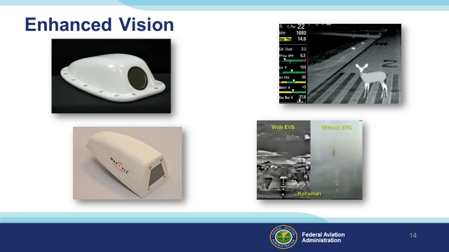 | Slide 17  Infrared cameras are available for installation on GA airplanes and their output can be displayed on multi function displays. Of course it’s nice to be able to see wildlife and other obstructions on the runway but they’re also quite useful in depicting terrain in weather or on a dark night.  A word of caution though. Enhanced vision technology takes some getting used to. You’ll have to make the transition to visual reference at some point and that can be a challenge.  Next Slide)
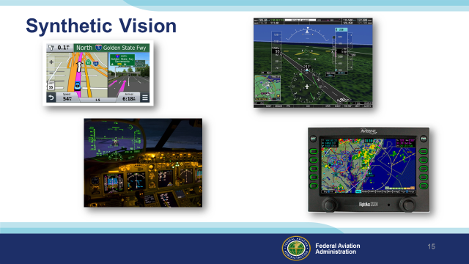 | Slide 18  For some time now, we’ve been able to combine imagery from sensors and navigation systems, with our view out the window to see the world as never before. We call this Synthetic Vision (Click)  Using information from navigation databases we can create a picture of the flight environment and overlay that picture with aircraft instrumentation, and weather information to create a single image that contains all of the information necessary for safe flight operations. (Click)  Developed for tactical military flying, the HUD or Head Up Display presents information from aircraft instrument displays directly in pilots’ fields of view as they look through their wind screens. HUD technology is already installed in many airline cockpits and it’s making its’ way to General Aviation as well.  (Next Slide)
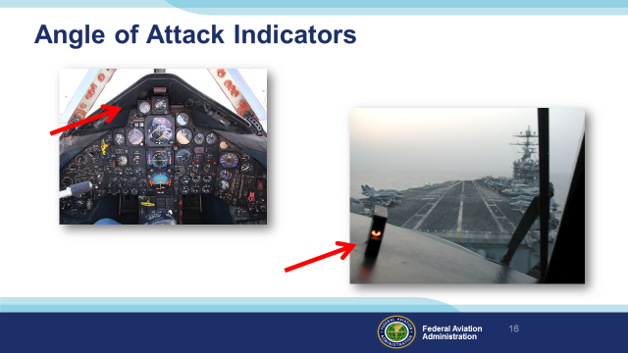 | Slide 19  Military aircraft have had AOA indicators for years. They’re essential to getting optimum performance in challenging situations but also very useful in routine flying as well. Only recently have they become more available and affordable for GA aircraft.  Next Slide)
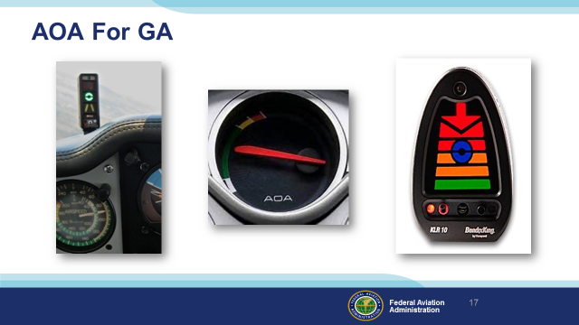 | Slide 20  AOA indicators are showing up on many new aircraft and there are also a number of affordable options for retrofit as well. Angle of attack sensing & display that go a long way toward reducing the number of stall/spin accidents.  Next Slide)
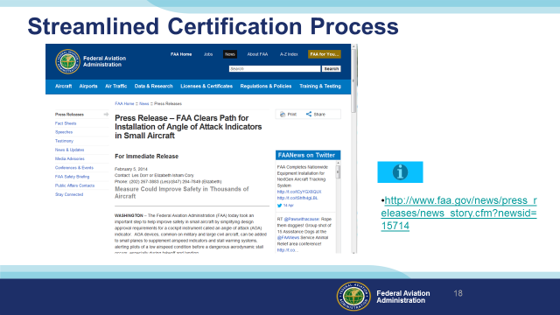 | Slide 21  FAA’s Small Airplane Directorate has streamlined the process for production and retrofit approval of AOA devices.  Presentation Note: If you have an internet connection you can access the Press Release by clicking on the information button on the lower right of the screen.  (Next Slide)
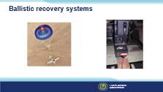 | Slide 22  Ballistic recovery systems (parachutes) are standard equipment on some general aviation aircraft. And there’s a growing market for retrofit installations. They are expensive but they do have an impressive record of performance and are credited with hundreds of lives saved.  (Next Slide)
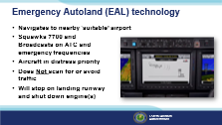 | Slide 23  Available on only a few aircraft types now, Emergency Autoland (EAL) technology is making its way into the General Aviation fleet. While most of us will not be flying with this technology it’s possible that we’ll be sharing the airspace with an aircraft under autonomous control. So, we need to know a little bit about how the system works. (Click)  When activated by pilot or passengers, the EAL system will select a suitable airport that can accommodate the aircraft and navigate to it. It will squawk 7700 and broadcast intentions on emergency and appropriate ATC and emergency frequencies. Within 12 miles of the selected airport the system will broadcast advisories on the appropriate ATC or Common Traffic Advisory (CTAF) frequency and on guard 121.5 MHz. (Click)  ATC and pilots should consider active EAL aircraft as priority traffic and remain clear of their flight path.  This is an important point because EAL aircraft do not scan for or avoid conflicting traffic.  Once on the runway, the EAL aircraft will stop, shut down engines, and direct occupants to exit the aircraft.  (Next Slide)
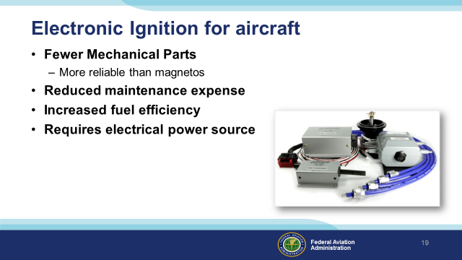 | Slide 24  As with automobiles fewer mechanical parts equals increased reliability which, in turn, increases maintenance intervals and reduces maintenance expense and increases fuel efficiency.  One caveat though; unlike magnetos which produce their own electrical energy, electronic ignition systems must have a separate power source. Still – replacing one magneto can yield significant benefits in longevity and fuel economy.  (Next Slide)
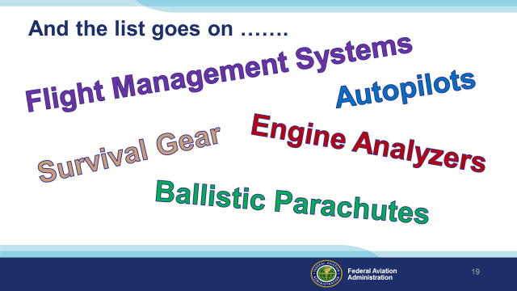 | Slide 25  And the list goes on. It seems like there’s a new product every week. They’re all great of course but how many improvements can you make to one airplane and still have room for people and their luggage?  There’s one major safety asset that we haven’t yet discussed and I’ll bet you know what it is.  Presentation note: Pause for audience suggestions….. Then”  (Next Slide)
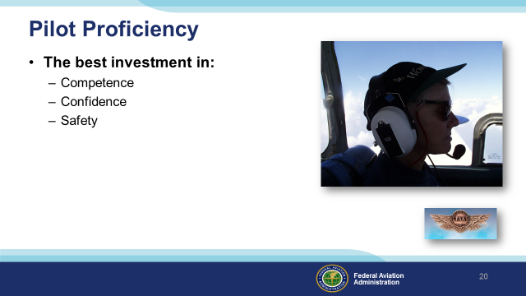 | Slide 26  Well trained, proficient pilots are competent, confident, and safe. That’s why we recommend investing in a robust, comprehensive proficiency training program. There’s simply no better way to ensure flight safety.  (Next Slide)
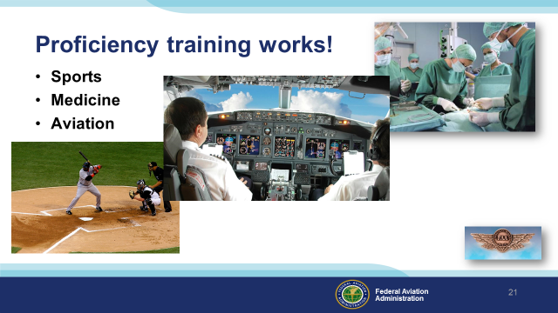 | Slide 27  Can you imagine how well professional athletes would perform if they didn’t practice between games or stay in shape during the off season? (Click)  Would you choose to be treated by doctors who had no continuing education since graduating from medical school? (Click)  Or how about a professional pilot flight crew who never train for emergencies?  Pros know that proficiency is not a destination but rather a journey that never ends.  Regular training keeps the them at peak performance every time they take to the air.  (Next Slide)
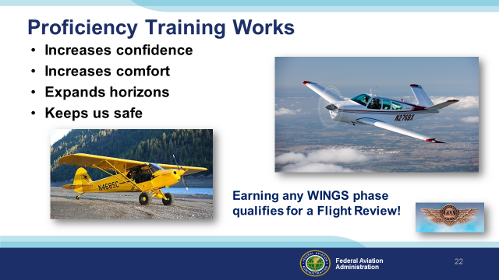 | Slide 28  Proficiency training works for General Aviation pilots too. Pilots who participate in the FAA WINGS Pilot Proficiency program fly with more confidence. They and their passengers are comfortable in the air. And proficiency training can expand our horizons by exploring the operational capabilities of our present aircraft or introducing us to more complex and capable planes as well as more challenging destinations.  Most importantly - proficiency training keeps us safe. (Click)  And pilots who earn WINGS phases also qualify for a flight review.  (Next Slide)
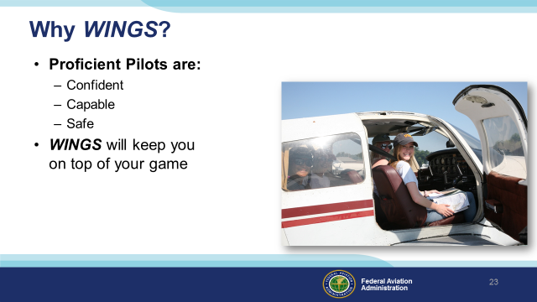 | Slide 29  So why WINGS? Well proficiency is key to success in almost every thing worth doing – especially flying. Proficient pilots are confident, capable, and safe.  WINGS is a proficiency training system specifically designed for general aviation pilots and, regular participation will keep you on top of your flying game.  (Next Slide)
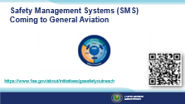 | Slide30  Safety Management Systems are a set of policies and processes that can increase the safety and efficiency of any flight operation. And FAA is bringing SMS to General Aviation. You may have heard of SMS but thought it was only for large organizations but actually SMS can be scaled to fit any operation large or small.  There are 4 major components to a Safety Management System (Click)  Safety Policy – a documented commitment to safety that runs from the head of an organization to its newest member. (Click)  Safety Risk Management – a process that identifies hazards within an operation, determines to what extent an identified hazard may impact flight safety, and controls the risk of occurrence to an acceptable level. (Click)  Safety Assurance – By collecting and analyzing information derived from safety performance data Safety Assurance ensures the performance and effectiveness of Safety Risk Controls. (Click)  Safety Promotion communicates safety information and commitment throughout the organization. (Click)  You can find more information about Safety Management Systems at the URL on the Screen.  (Next Slide)
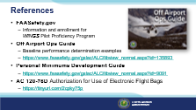 | Slide 31  Here are a few references for additional information:  FAASafety.gov is the FAASTeam website where you’ll find a wealth of safety information. You can enroll and track your progress in the FAA WINGS Pilot Proficiency Program here.  Look in the FAASafety.gov library for the Off Airport Operations Guide. In it you’ll find instructions for developing a short field performance baseline together with other useful information on operating to small fields.  Also in the FAASafety.gov Library – the Personal Minimums Development Guide – Your documented proficiency performance can be used to develop minimums that are tailored to you, your aircraft, and your mission.  I’ll leave this slide on screen while I take some questions from the audience.  Presentation note: Take questions from the audience while they copy information from the screen. Then:  (Next Slide)
 | Slide 32  Presentation Note: You may wish to provide your contact information and main FSDO phone number here. You can also add WINGSPro contact information.  Modify with your information or leave blank.  (Next Slide)
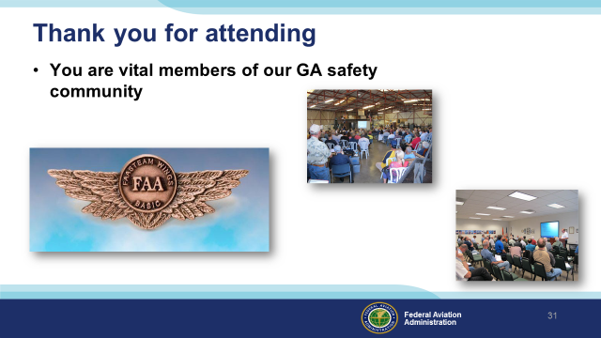 | Slide 33  Your presence here shows that you are vital members of our General Aviation Safety Community. The high standards you keep and the examples you set are a great credit to you and to GA.  Thank you for attending.  (Next Slide)
Slide 34

(The End)

IMPORTANT – Once you have completed outreach on this topic, please help us track the outreach you have done by entering a PTRS record.
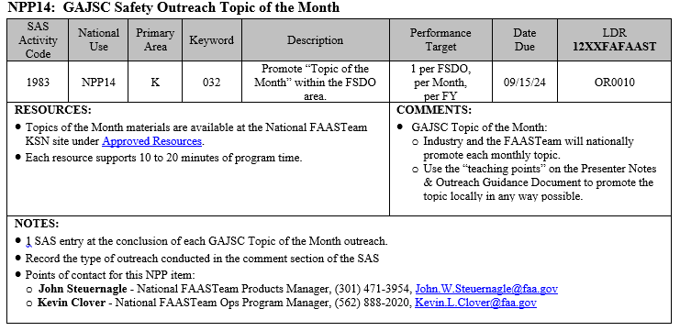
Appendix I – Equipment and Staging
Equipment:
- Projection Screen & Video Projector suitable for expected audience
  - Remote computer/projector control available at lectern or presenter location
    - In lieu of remote – detail a Rep to computer/projector control.
- Presentation Computer
  - Note: It is strongly suggested that the entire program reside on this computer.
- Back up Projector/Computer/Media as available.
- PA system suitable for expected audience
  - Microphones for Moderator and Panel
    - Optional Microphone (s) for audience
- Lectern (optional)
Staging:
- Arrange the projection screen for maximum visibility from the audience.
- Equip with PA microphones
- Place Lectern to one side of screen. This will be used by presenters and moderator

